Ideation Phase
Define the Problem Statements

Date | 23 January 2026
Team ID | LTVIP2026TMIDS90862
Project Name | Prosperity Prognosticator: Machine Learning for Startup Success Prediction
Maximum Marks | 2 Marks

Customer Problem Statement Template:
This section defines the core problem faced by users of the system. Investors, entrepreneurs, and policymakers often struggle to determine whether a startup will succeed or fail based on available business and financial data. Decision-making is usually based on assumptions, limited experience, or incomplete analysis.
The challenge is to develop a system that can analyze historical startup data and provide a data-driven prediction of startup success. By understanding this problem, the project aims to build a machine learning model that supports informed and objective decision-making.
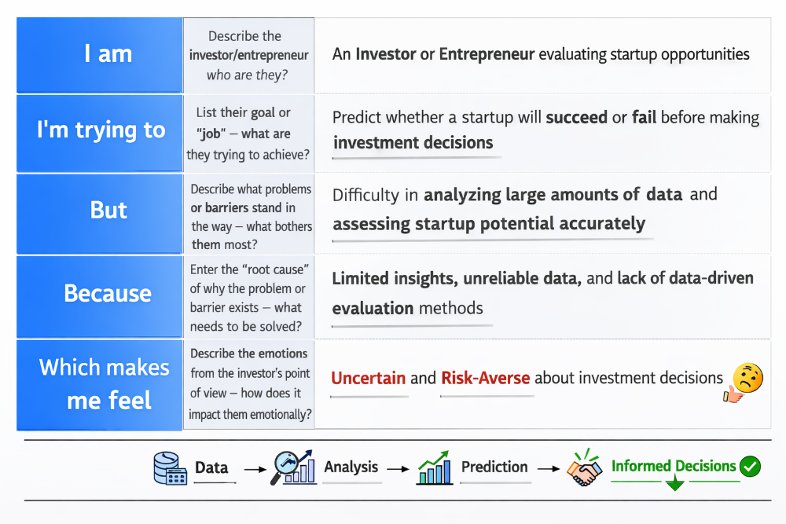

Example:
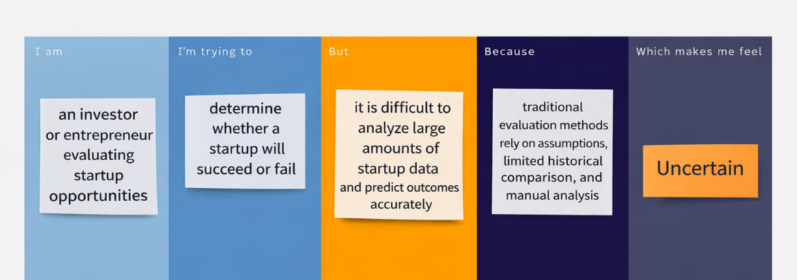

Problem Statement (PS) | I am (Investor) | I’m trying to | But | Because | Which makes me feel
PS-1
PS-2

